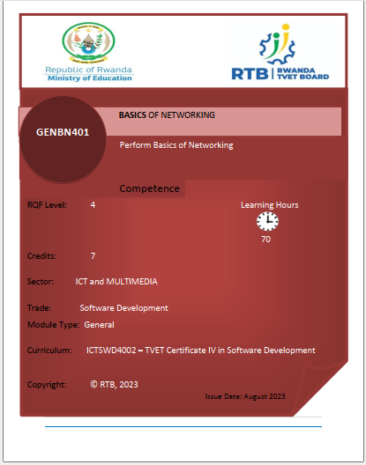

Purpose statement
This module Describes the skills, Knowledge and attitude required to Perform basic Networking. This module intended to prepare students Pursuing TVET in Level 4 Software Development. At the end of this module, the students will be able to Establish network media connectivity, Perform Basic Network Configuration, Maintain Network system

Learning outcome 1: Establish network media connectivity

Indicative content 1.1: Identification of Network requirements.
- Description of network concepts and technologies
- Basic definitions:
A network consists of two or more computer that are linked in order to share resources (such as printers and CDs), exchange files, or allow electronic communications. The computer on a network may linked through cables, telephone lines, radio waves, satellites, or infrared light beams.

- Network classifications/types:
Classifying network by components roles
Networks can be classified into different categories based on various criteria, including their size, scope, purpose, and architecture. Here are some common network classifications:
- Based on Size:
  - Personal Area Network (PAN): A small network typically within a range of a few meters, used for connecting personal devices like smartphones, laptops, and tablets.
  - Local Area Network (LAN): Covers a limited geographic area, such as a home, office, or campus. LANs connect devices like computers, printers, and servers.
  - Metropolitan Area Network (MAN): Larger than a LAN but smaller than a WAN, covering a city or a large campus. MANs are used by organizations with multiple locations in a city.
  - Wide Area Network (WAN): Spans a large geographic area, often connecting LANs or MANs across different cities, regions, or countries. The internet is the most extensive WAN.
  - Global Area Network (GAN): A network that covers a global or international scale, often using satellite links and undersea cables. The internet can be considered a GAN.
- Based on Purpose:
  - Public Network: Open to the public, such as the internet, where anyone can access and use its resources.
  - Private Network: Restricted to a specific organization, group, or individuals. Examples include corporate intranets and private cloud networks.
  - Hybrid Network: Combines elements of both public and private networks, often for security and cost considerations. Hybrid clouds, which use a mix of public and private cloud services, are an example.
  - Peer-to-Peer (P2P) Network: Devices in this type of network communicate directly with each other without a central server. Common in file sharing applications.
- Based on Topology:
  - Star Topology: Devices connect to a central hub or switch.
  - Bus Topology: Devices share a single communication line.
  - Ring Topology: Devices form a closed-loop or ring.
  - Mesh Topology: Devices connect to multiple other devices, creating redundancy.
  - Hybrid Topology: A combination of two or more different topologies.
- Based on Architecture:
  - Client-Server Network: Devices are categorized as clients (requesters) and servers (providers of services or resources). Common in corporate networks and the internet.
  - Peer-to-Peer (P2P) Network: Devices communicate directly with each other without a central server. Often used in file-sharing applications and some blockchain networks.

- Network benefits
Main benefits of networks include:
Networks offer numerous benefits across various domains and industries due to their ability to connect devices, systems, and people.
- Communication: Networks enable efficient and effective communication, allowing people to share information, collaborate, and exchange messages in real time. This is crucial for business operations, remote work, and social interactions.
- Data Sharing: Networks facilitate the sharing of data and resources. Users can access shared files, databases, and applications, leading to improved productivity and collaboration.
- Resource Sharing: Devices and resources such as printers, scanners, and storage devices can be shared across a network, reducing costs and optimizing resource utilization.
- Centralized Data Management: Networks allow for central storage and management of data, making it easier to back up, secure, and access data when needed.
- Remote Access: With network connectivity, users can access data and applications from remote locations, enabling flexible work arrangements and remote troubleshooting and support.
- Cost Efficiency: Sharing resources and centralized management can lead to cost savings in terms of hardware, software, and maintenance.
- Global Connectivity: The internet, a global network, offers access to information, services, and markets worldwide, fostering globalization and international trade.
- Security: While networks can pose security challenges, they also enable the implementation of security measures, such as firewalls, intrusion detection systems, and encryption, to protect data and resources.
- Data Backup and Disaster Recovery: Networks make it easier to back up data and implement disaster recovery plans, reducing the risk of data loss and downtime.
- Resource Optimization: Networks can optimize resource usage through load balancing and efficient routing, ensuring that resources are used effectively.
- Monitoring and Management: Network management tools allow administrators to monitor network performance, troubleshoot issues, and make adjustments to optimize network operation.
- Innovation and Development: Networks are the foundation for many technological advancements, such as the Internet of Things (IoT), cloud computing, and edge computing, driving innovation in various industries.
- Accessibility and Inclusivity: Networks can enhance accessibility by providing online education, telehealth services, and access to information for people with disabilities or those in remote areas.
- Environmental Benefits: By enabling remote work and virtual meetings, networks can reduce the need for commuting, leading to lower carbon emissions and environmental benefits.
- Entertainment and Content Delivery: Networks enable the streaming of movies, music, and online gaming, providing entertainment options and revenue streams for content creators.
- Research and Collaboration: Networks facilitate collaborative research, connecting scientists, researchers, and institutions globally, leading to advancements in various fields.
- E-commerce and Online Shopping: Networks have transformed the retail industry, making it possible for consumers to shop online, compare prices, and access a wide range of products and services.
- Community and Social Interaction: Social networks and online communities bring people together, fostering social interaction, information sharing, and support networks.

- Advantages and Disadvantages of network
Networks, whether they are computer networks, social networks, or any other type of interconnected systems, come with various advantages and disadvantages. Here are some of the key advantages and disadvantages of networks:
Advantages of Networks:
- Communication: Networks enable efficient communication between individuals, devices, or systems, regardless of their physical locations. This facilitates the exchange of information, collaboration, and coordination.
- Resource Sharing: Networks allow for the sharing of resources such as files, printers, and software applications. This can lead to cost savings and improved efficiency in organizations.
- Centralized Data Management: In computer networks, data can be stored centrally, making it easier to manage and backup. This centralization can enhance data security and accessibility.
- Remote Access: Networks enable remote access to resources and data, allowing individuals to work from different locations and enhancing flexibility.
- Redundancy and Reliability: Some networks are designed with redundancy, which means that if one component fails, there are backup options to ensure system reliability.
- Resource Optimization: Networks can optimize resource usage by load balancing and efficient routing, ensuring that resources are used effectively.
- Global Connectivity: The internet is a global network that provides access to information and services worldwide, facilitating international communication and commerce.
Disadvantages of Networks:
- Security Risks: Networks can be vulnerable to security threats such as hacking, viruses and malware. Protecting networked systems is an ongoing challenge.
- Complexity: As networks grow in size and complexity, they become more challenging to manage and troubleshoot. Complex networks may require specialized expertise.
- Maintenance Costs: Networks require ongoing maintenance, including hardware upgrades, software updates, and security measures. These costs can add up over time.
- Privacy Concerns: Networks can potentially compromise individual privacy, as personal data may be accessible or vulnerable to surveillance.
- Downtime: Network failures or outages can disrupt communication and business operations. Downtime can result in financial losses and customer dissatisfaction.
- Bandwidth Limitations: In data networks, bandwidth limitations can lead to slow data transfer speeds and congestion, affecting performance.
- Technical Issues: Networks can experience technical problems, including connectivity issues, hardware failures, and software glitches, which may require troubleshooting and downtime.
It's important to note that the advantages and disadvantages of networks can vary depending on the specific type of network (e.g., computer networks, social networks, telecommunications networks) and their intended use.

- Network technologies
Network technologies encompass a wide range of tools, protocols, hardware, and software used to create and manage computer networks.
These technologies enable the efficient transfer of data, communication between devices, and the sharing of resources.
Here are some key network technologies:
- Ethernet: Ethernet is a widely used wired networking technology that defines how data packets should be placed on a network cable. It operates over various media types, including copper and fiber-optic cables, and supports different data speeds (e.g., 10/100/1000/10000 Mbps).
- Wi-Fi (Wireless LAN): Wi-Fi technology enables wireless local area networks (WLANs). It allows devices to connect to a network without physical cables, making it especially useful for mobile devices like smartphones and laptops. Various Wi-Fi standards (e.g., 802.11n, 802.11ac, 802.11ax) offer different data rates and features.
- Bluetooth: Bluetooth is a short-range wireless technology primarily used for connecting devices like smartphones, headphones, and IoT devices. It's commonly used for file sharing, audio streaming, and peripheral device connections.
- Cellular Networks: Cellular technology provides wireless connectivity for mobile phones and other devices. It includes generations like 2G, 3G, 4G, and 5G, with each generation offering improved data speeds and capabilities.
- IP (Internet Protocol): IP is a fundamental network protocol that governs how data packets should be addressed and routed across the internet. IPv4 (Internet Protocol version 4) and IPv6 (Internet Protocol version 6) are the most commonly used versions.
- TCP/IP (Transmission Control Protocol/Internet Protocol): TCP/IP is a suite of protocols used for communication over the internet and local networks. It includes protocols like HTTP, FTP, SMTP, and DNS, which enable various network services.
- DNS (Domain Name System): DNS is a technology that translates human-readable domain names (e.g., www.example.com) into IP addresses (e.g., 192.168.1.1). It's essential for browsing the internet.
- Firewalls: Firewalls are security devices or software that protect networks by monitoring and controlling incoming and outgoing network traffic. They can block malicious traffic and unauthorized access.
- Routers: Routers are network devices that connect different networks and determine the best path for data packets to travel between them. They play a critical role in directing traffic on the internet.
- Switches: Switches are devices that connect multiple devices within a local network and efficiently forward data packets only to their intended recipients. They operate at Layer 2 (Data Link Layer) of the OSI model.
- Load Balancers: Load balancers distribute network traffic across multiple servers to ensure even utilization and high availability. They are often used in web applications and server farms.
- VPN (Virtual Private Network): VPN technology creates a secure and encrypted connection over a public network, such as the internet. It's commonly used for remote access, privacy, and secure communication.
- VoIP (Voice over IP): VoIP technology allows voice calls to be transmitted over IP networks. It's the basis for services like Skype, Zoom, and business phone systems.
- IoT (Internet of Things) Protocols: IoT networks use various protocols such as MQTT, CoAP, and Zigbee to enable communication between IoT devices and platforms.
These are just a few examples of network technologies, and the field is constantly evolving as new innovations emerge. Network technologies are crucial for modern communication, data sharing, and the functioning of the internet.

- Network topology types
Network topology refers to the physical or logical layout of devices and connections in a computer network.
Different network topologies are used depending on the specific requirements of the network, such as scalability, fault tolerance, and cost.
Here are some common network topology types:
- Star Topology:
  - Description: In a star topology, all devices (computers, printers, etc.) are connected to a central hub or switch.
  - Advantages: Easy to install and manage, fault isolation (a problem in one device does not affect others), centralized control.
  - Disadvantages: If the central hub or switch fails, the entire network can be affected.

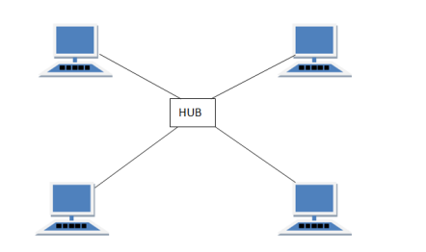

- Bus Topology:
  - Description: In a bus topology, all devices are connected to a single central cable (the "bus").
  - Advantages: Simple and inexpensive to set up, suitable for small networks.
  - Disadvantages: Susceptible to cable failure, limited scalability, performance degrades as more devices are added.

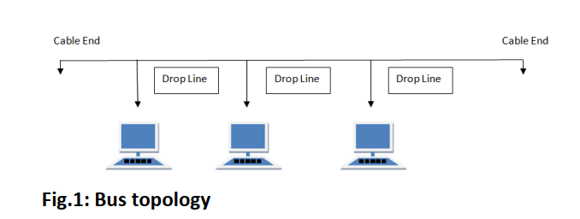

- Ring Topology:
  - Description: In a ring topology, devices are connected in a circular or ring-like fashion, where each device is connected to exactly two other devices.
  - Advantages: Even data distribution, no collisions, predictable performance.
  - Disadvantages: A failure in one device or cable segment can disrupt the entire network, typically slower than star or bus topologies.

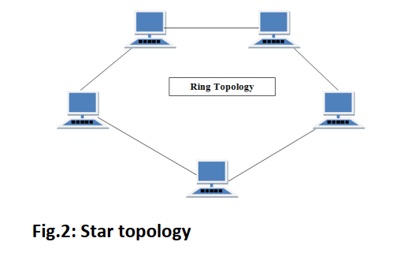
- Mesh Topology:
  - Description: In a mesh topology, every device is connected to every other device. There are two variations: full mesh (all devices connect to all others) and partial mesh (only some devices connect to all others).
  - Advantages: High redundancy, fault tolerance, can handle heavy traffic loads.
  - Disadvantages: Expensive to implement and manage, complex cabling, scalability challenges in full mesh.

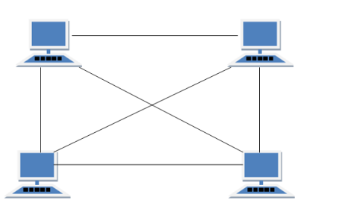
- Hybrid Topology:
  - Description: Hybrid topologies are a combination of two or more different topology types. For example, a network might use a combination of star and ring topologies.
  - Advantages: Can leverage the strengths of multiple topologies, adaptable to specific network requirements.
  - Disadvantages: Can be complex to design and manage.
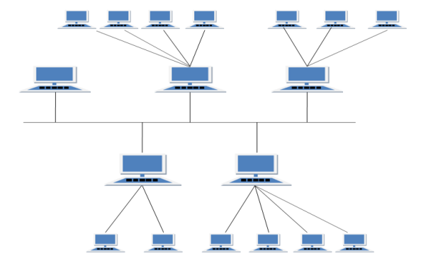

- Tree Topology (Hierarchical Topology):
  - Description: Tree topology combines characteristics of star and bus topologies. Multiple star-configured networks are connected to a linear bus backbone.
  - Advantages: Scalable, combines benefits of star and bus topologies.
  - Disadvantages: Costly and complex to implement, failure of the backbone can disrupt the entire network.
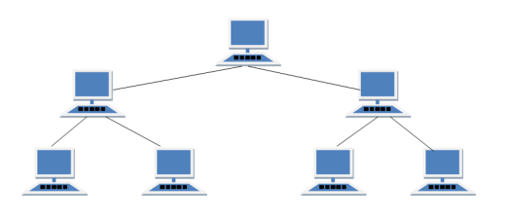
Each topology has its own strengths and weaknesses, and the right choice can greatly impact a network's performance and reliability.

- Network components

Computer networks consist of various components that work together to facilitate communication, data sharing, and resource access among connected devices.
These components can be categorized into several broad categories:
- End Devices:
  - Computers: Such as desktops, laptops, servers, and workstations.
  - Mobile Devices: Such as smartphones, tablets, and wearable devices.
  - Printers: For document and image printing.
  - IP Phones: Voice-over-IP (VoIP) phones for voice communication over the network.
  - IoT Devices: Sensors, cameras, and other Internet of Things (IoT) devices.
- Networking Hardware:
  - Router: A device that connects different networks and directs traffic between them.
  - Switch: A device that connects devices within a local network and efficiently forwards data packets based on MAC addresses.
  - Hub: An older networking device that broadcasts data packets to all connected devices.
  - Access Point (AP): Facilitates wireless connectivity by allowing devices to connect to a wired network wirelessly (Wi-Fi).
  - Firewall: A security device or software that monitors and controls network traffic, often used to protect against unauthorized access and threats.
  - Modem: Converts digital data from a network into a format suitable for transmission over specific types of media (e.g., DSL, cable, fiber).
  - Gateway: Acts as an entry and exit point between different networks, translating data formats and protocols.
- Network Infrastructure:
  - Cabling: Includes Ethernet cables (e.g., CAT6), fiber-optic cables, and coaxial cables for wired connections.
  - Wireless Infrastructure: Access points, wireless controllers, and antennas for Wi-Fi networks.
  - Network Servers: Systems responsible for hosting applications, files, and services on the network.
  - Data Centers: Facilities housing network equipment, servers, and storage devices for centralized data processing and storage.
  - Racks and Cabinets: Housing units for organizing and securing network equipment.
- Networking Software and Protocols:
  - Operating Systems: Such as Windows, Linux, and macOS, which include networking features and protocols.
  - Network Protocols: TCP/IP, UDP, HTTP, FTP, SNMP, DNS, DHCP, etc., enabling communication and data transfer.
  - Network Management Software: Tools for monitoring, configuring, and managing network devices.
  - Virtualization Software: Such as VMware and Hyper-V, used for creating virtual network environments and virtual servers.
- Network Services and Applications:
  - Email Services: Like Microsoft Exchange and SMTP/POP/IMAP servers.
  - Web Services: Hosting websites and web applications.
  - File Sharing Services: Such as Network Attached Storage (NAS) and cloud-based file sharing platforms.
  - VoIP Services: Voice over IP services for telephony and video conferencing.
  - DNS Servers: Resolving domain names to IP addresses.
  - DHCP Servers: Assigning IP addresses automatically to devices on the network.
- Security Components:
  - Firewalls: As mentioned earlier, protecting the network from threats.
  - Intrusion Detection Systems (IDS) and Intrusion Prevention Systems (IPS): Monitoring and preventing unauthorized access and attacks.
  - Antivirus and Antimalware Software: Protecting end devices from malicious software.
  - Virtual Private Networks (VPNs): Securing data transmitted over public networks.
  - Authentication and Access Control Systems: Managing user access rights and permissions.

- Materials
- Network Cables (twisted, coaxial, and Fiber optic)


Twisted pair cabling is a type of communications cable in which two conductors of a single circuit are twisted together for the purposes of improving electromagnetic compatibility.
Image 1.Twisted pair cable

Coaxial cable is a type of transmission line, used to carry high-frequency electrical signals with low losses. It is used in such applications as telephone trunk lines, broadband internet networking cables, high-speed computer data busses, cable television signals, and connecting radio transmitters and receivers to their antennas.
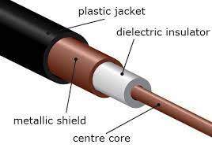
Image 2. Coaxial cables
A fiber-optic cable, also known as an optical-fiber cable, is an assembly similar to an electrical cable but containing one or more optical fibers that are used to carry light

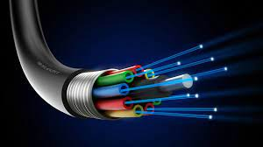
- Trunk

A trunk is a communication line or physical link, such as a wire or optical line, designed to carry multiple signals simultaneously A networking trunk can consist of several wires, cables or fiber optic strands bundled together in a single physical cable to maximize the available bandwidth.

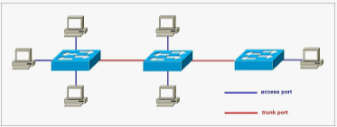

- Connectors

Connectors are physical interfaces used to connect network devices and cables. They enable the transmission of data between different components within a network infrastructure.

Common Types of Network Connectors
- Ethernet Connectors

RJ-11 Connectors
RJ-11 connectors have the capacity for six small pins. However, in many cases, only two or four pins are used. For example, a standard telephone connection uses only two pins, and a DSL modem connection uses four pins. They have a small plastic flange on top of the connector to ensure a secure connection.
RJ-11: Primarily used for telephone connections, but can also be used for some older Ethernet networks. It has four pins.

The following image shows RJ-11 connectors.
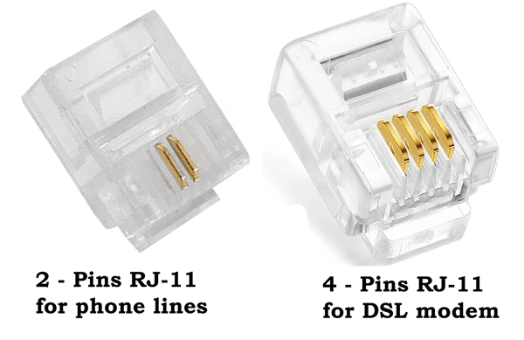

RJ-45 connectors
RJ-45 connectors look likes RJ-11 connectors, but they are different. They have 8 pins. They are also bigger in size than RJ-11. RJ-45 connectors are mostly used in computer networks. They are used with STP and UTP cables. Some old Ethernet implementations use only four of the eight pins. Modern Ethernet implementation uses all 8 pins to achieve the fastest data transfer speed.
RJ-45: The most common Ethernet connector, used for wired Ethernet networks. It has eight pins and is typically found on network interface cards (NICs), routers, switches, and hubs.

The following image shows RJ-45 connectors.
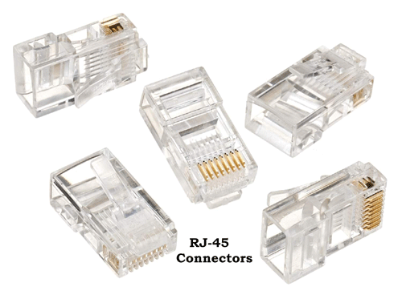



Serial Connectors

DB-9 (RS-232) connectors
A DB-9 or RS-232 connector connects a device over a serial port. It has 9 pins. It is available in both male and female connectors. It is used for asynchronous serial communication. The other side of the cable can be connected to any popular connector type. For example, you can connect one side of the cable with a DB-9 connector and the other side of the cable with another DB-9 connector or with an RJ-45 connector or with a USB connector.
The following image shows DB-9 connectors.
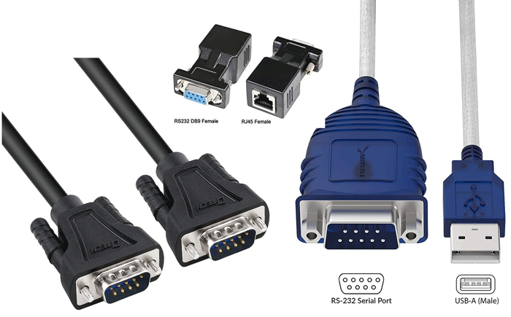
One of the most popular uses of a DB-9 connector is to connect the serial port on a computer with an external modem.

Universal serial bus (USB) connectors
USB connectors are the most popular. They support 127 devices in the series. All modern computers have USB ports. Most devices that you can connect to the system have USB ports. Some examples of devices that support or have USB ports are mice, printers, network cards, digital cameras, keyboards, scanners, mobile phones, and flash drives.
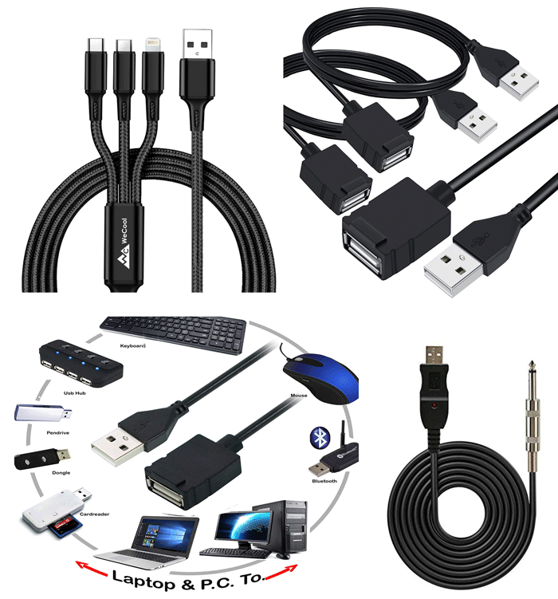
If the device has a USB port, you can use a cable that has a USB connector on both ends to connect the device to the computer. If the device does not have a USB port, you can still connect the device to the USB port. For that, you can use a cable that has a USB connector on one side and the corresponding connector on the other.

- Cable Ties :

- Cable clips

- Cable Sockets
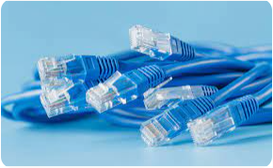
The RJ45 socket is a standard socket for the Internet and is used to connect network devices. It consists of a plug for connecting a cable. The RJ45 socket usually contains one plug, but there can be up to four. Sockets are used to connect the jack to a patch panel or to connect a computer.

- Wall plugs
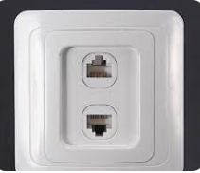
A network wall socket, also called a UTP wall socket, is a socket for a computer network. These boxes are used to neatly terminate fixed network cabling.

- Tools

- Cutting Tools and Stripping tools

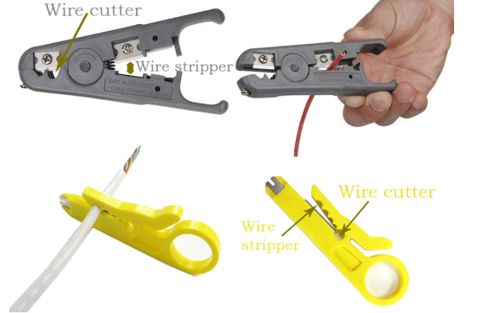
- Drilling Tools

Drilling tools are end-cutting tools designed for producing holes in a workplace.
- Fixing Tool
Types of fixing tools
• 1 Nails.
• 2 Screws.
• 3 Nuts and bolts.
• 5 Rivets.
• 6 Adhesives.
• 8 Welding.


- Patching Panel

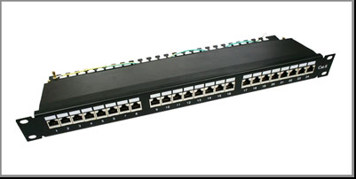
How to Wire a Patch Panel
- Buy a patch panel. ...
- Design a cable map. ...
- Remove cable jackets from incoming Ethernet cables. ...
- Remove internal plastic jackets (if any) ...
- Untwist and spread the cable wires. ...
- Set your wires to the panel connector. ...
- Complete your connections.
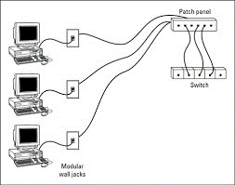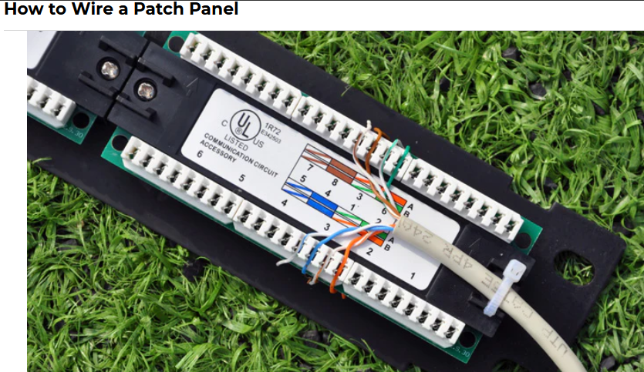
Internet connections are required in areas with large populations such as business settings and work environments. In such areas where employees are spread across various offices and floors, the computers are oftentimes connected to central servers. It is so simple to wire the internet to the server, but obviously creates a large build-up of cables around the server area, which must be routed and terminated with absolute care. Because it is barely possible to hardwire each Ethernet cable, the solution is to terminate the incoming cables at a patch panel. This makes it easy to connect the server to the patch panel with the help of short cables, which can as well be moved easily when there is a need to. To achieve this kind of wiring, consider the following guide on how to wire a patch panel:

Buy a patch panel
When buying the patch panel, ensure it has 110 style insulation displacement connectors. Similarly, make sure that there are enough patch connectors that can fit the Ethernet cables. Be sure to conduct a little research so that you can buy the right patch panel.
left arrow
right arrow

Design a cable map
This will be the only guide indicating to which panel connector a particular incoming cable is connected. Remember, there could be a need for system upgrades changes in future, so prepare the right map and label the patch panels accurately for this as well as problem diagnosis.

Remove cable jackets from incoming Ethernet cables
Cable jackets must be removed from the incoming Ethernet cables, and this is best done with the help of wire strippers. Cut the jacket approximately 1.5 inches from the cable, remove and discard it. Wire strippers are also available in hardware and electrical stores.

Remove internal plastic jackets (if any)
Sometimes you will be handling Cat6 type incoming Ethernet cables. These often come with an internal plastic jacket, which too should be removed. Use wire cutters in this operation and exercise absolute care. If you are using Cat5e incoming cables, however, you will not be required to undertake this step.

Untwist and spread the cable wires
Inside the Ethernet cables, you will find four pairs of twisted wires. Unwind these wires, but be careful not to mix them up. Four of the wires have solid colors while the rest have a strip of white alongside the solid color.

Set your wires to the panel connector
Each of the wires should then be set to the patch panel. The connector pins are fitted with labels containing color codes, which should guide you in selecting the type of wire that goes to a particular connector.

Complete your connections
Using a patch panel punch down tool, press each of the wires down firmly. This ensures that the wire is held in place by the insulation connector teeth. If this tool has a cutting edge, place it over the cut end of your Ethernet cables to cut off any extra wire while pressing. If it lacks the cutting edge, on the other hand, use your wire cutter to remove the excess wires that are spread over the edges of your connector.

How to make RJ45 cable
RJ45 cable is used for connect the ALL HMI and engineer station through a switch to communicated each other. It is used to download the any modification and which is made in graphics in engineering station.RJ45 cable also used for communicate the printer with computer
Required tool and materials:
- Ethernet Cable – Category 5e or CAT5e or CAT6
- RJ-45 Crimping tool
- RJ45 Crimp able Connectors
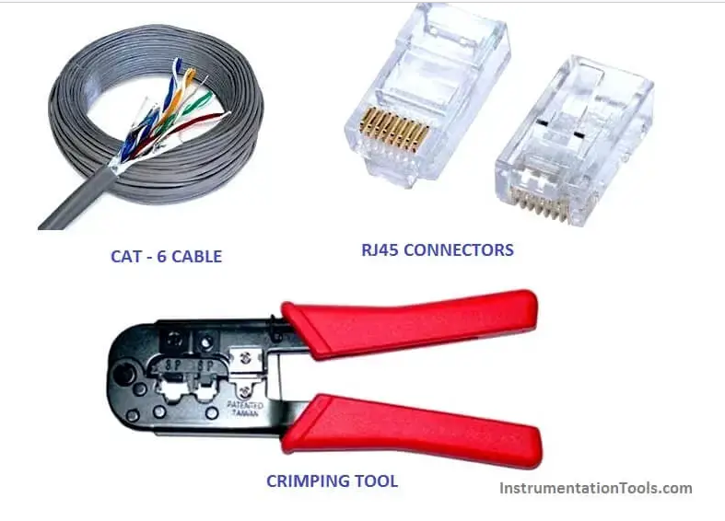
Introduction: There are four pairs of wires in an Ethernet cable, and an Ethernet connector (8P8C) has eight pin slots. Each pin is identified by a number, starting from left to right, with the clip facing away from you.
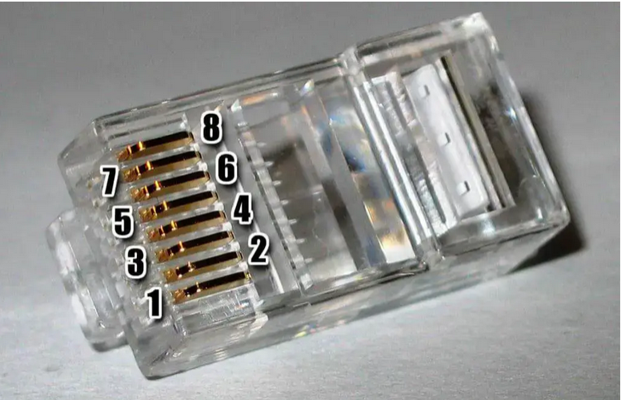
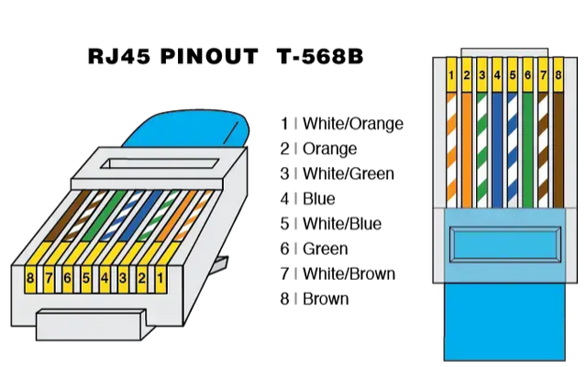
There is two kinds of Ethernet cable is used for communication.
- Straight Through
- Cross over cable
Straight Through cable:
STRAIGHT THROUGH Ethernet cables are the standard cable used for almost all purposes, and are often called “patch cables”. It is highly recommend you duplicate the color order as shown on the left. Note how the green pair is not side-by-side as are all the other pairs. This configuration allows for longer wire runs.
Important Instruction: Always remember that both end connector clip facing away from you when check the color.
CROSSOVER CABLES –
The purpose of a Crossover Ethernet cable is to directly connect one computer to another computer (or device) without going through a router, switch or hub.
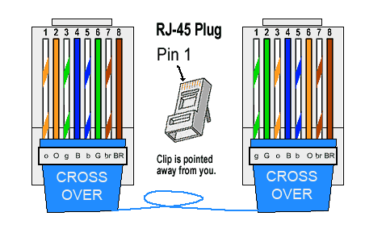
Procedure to make RJ45 cable :
Step 1: Cut into the plastic sheath about 1 inch (2.5 cm) from the end of the cut cable. Do not cut deep which may cause damage the insulation of core.
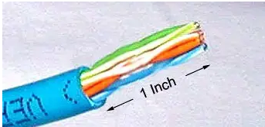
Step 2: Unwind and pair the similar colors. Pinch the wires between your fingers and straighten them out in a sequence of color as u want to make cable (Straight cable or cross over cable). The color order is important to get correct
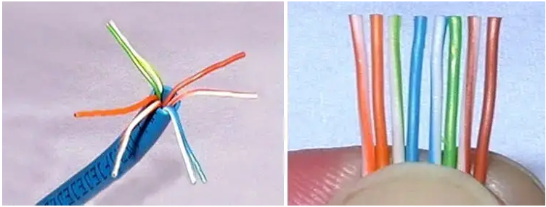
Step 3: A straight cut across the 8 wires to shorten them to 1/2 Inch (1.3 cm) from the cut sleeve to the end of the wires by crimping tool. Carefully push all 8 unstrapped colored wires into the connector. Plastic sleeve should be inserted proper in connector.
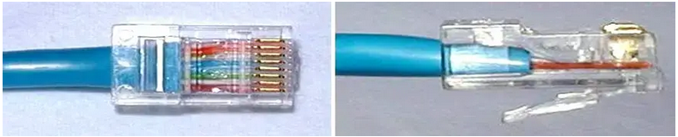
Wrong way: The plastic sleeve is not inside the connector where it can be locked into place. The wires are too long. The wires should extend only 1/2 inch from the blue cut sleeve. The wires do not go all the way to the end of the connector. The wires are too short.
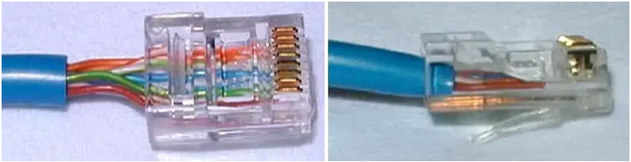
Crimping the cable: Carefully place the connector into the Ethernet Crimper and cinch down on the handles tightly. The copper splicing tabs on the connector will pierce into each of the eight wires. There is also a locking tab that holds the plastic sleeve in place for a tight compression fit. When you remove the cable from the crimper, that end is ready to use.
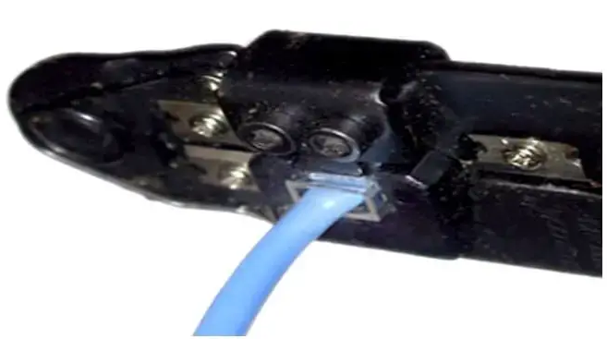
Test the cable: Check the continuity of both connectors each other .Check the cable threw a cable tester or ping from a computer. To check the cable through computer connects both connector in two computers for cross cable and straight cable connect through a switch then ping the computer.

N.B: When you connect two devices of different types together, you use a straight through cable. When you connect two devices of the same type together, you use a crossover cable. All cables are straight through if you insert a network device between two devices of the same kind.
- Crimping tools
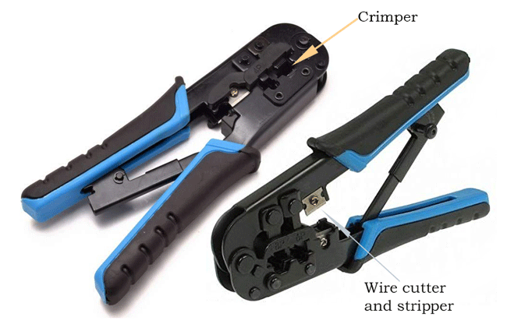
Crimping tools are used for the following purposes.
- To cut the network cable of the required length from the bundle.
- To remove the outer and inner jackets of the network cable.
- To attach the connectors on both ends of the cable.

- Testing tool
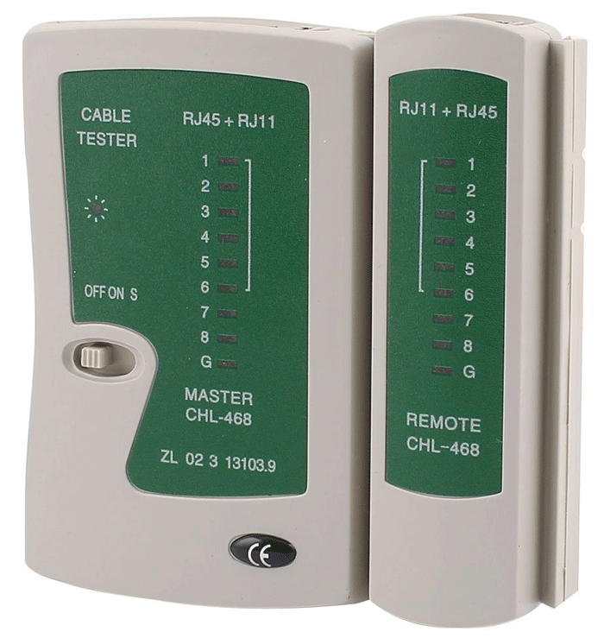a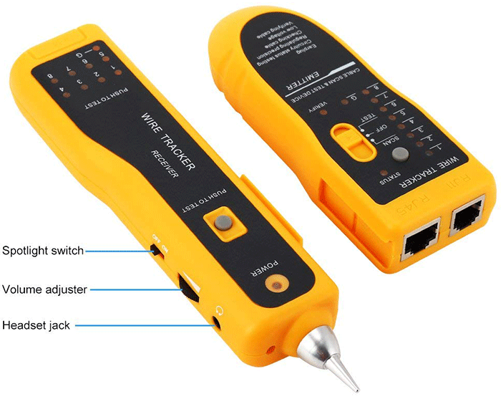

Network cable testing and troubleshooting tools
A network cable testing and troubleshooting tool is used for the following purposes.
- To measure the length of a segment or network cable.
- To detect loose connectors.
- To identify an un-labeled network cable from all network cables.
- To find a break in the network cable.
- To certify the cable installation.

- Equipment
- Computer: A computer is a machine that can be programmed to carry out sequences of arithmetic or logical operations (computation) automatically.

- UPS: An uninterruptible power supply (UPS) or uninterruptible power source is a type of continual power system that provides automated backup electric power to a load when the input power source or mains power fails. A UPS differs from a traditional auxiliary/emergency power system or standby generator in that it will provide near-instantaneous protection from input power interruptions by switching to energy stored in battery packs, super capacitors.

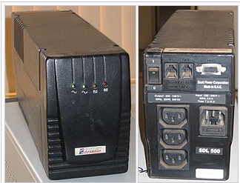

- Inverter: An inverter converts the DC voltage to an AC voltage. In most cases, the input DC voltage is usually lower while the output AC is equal to the grid supply voltage of either 120 volts, or 240 Volts depending on the country.

- Switch: A network switch is networking hardware that connects devices on a computer network by using packet switching to receive and forward data to the destination device. A network switch is a multiport network bridge that uses MAC addresses to forward data at the data link layer of the OSI model.
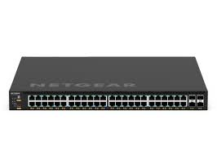
- Glue gun: Hot-melt adhesive, also known as hot glue, is a form of thermoplastic adhesive that is commonly sold as solid cylindrical sticks of various diameters designed to be applied using a hot glue gun.


- Rack:

What is a Network Rack?
Known by many names, a network rack is a metal frame chassis that holds, stacks, organizes, secures and protects various computer network and server hardware devices. The term “network” refers to the rack actually housing this type of hardware.

Network Rack Equipment
These racks can house a lot of different types of equipment. Network equipment is really just an umbrella term that encapsulates various kinds of technology. Some of these devices include the following:
- Switches – Multi-port, high-speed devices that receive data and redirect them to the correct destination on a local area network (LAN). Information can only go across a single network using a switch.
- Routers – Similar to switches, routers receive and forward information, but they can carry data over multiple networks. This is why, for example, different devices or networks can access the Internet using one single router.
- Modems – This device actually connects the source of your internet to your router. This is typically done using an ethernet cord.
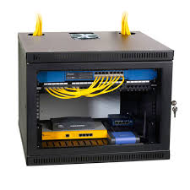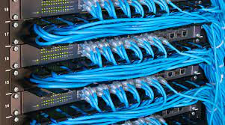
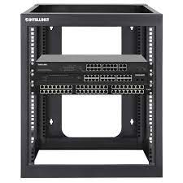

- Brackets
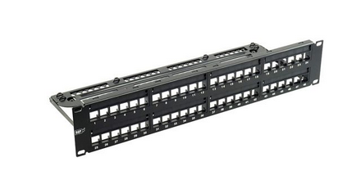
- Patch panel: A patch panel in a local area network (LAN) is a mounted hardware assembly that contains ports that are used to connect and manage incoming and outgoing LAN cables. A patch panel provides a way to keep large numbers of cables organized, enabling flexible connectivity into network hardware located in a data center or an access or wiring closet.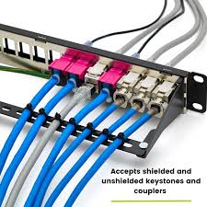
- Repeater
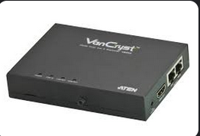
In telecommunications, a repeater is an electronic device that receives a signal and retransmits it. Repeaters are used to extend transmissions so that the signal can cover longer distances or be received on the other side of an obstruction.

10.Regenerator: : In the context of networking, a "regenerator" typically refers to a network device or component that is used to boost or regenerate the strength of optical signals. Optical signals can degrade as they travel long distances in optical fiber cables, and regenerators are employed to restore the signal quality.

Indicative content 1.2: Termination of Network cables
  - Network cables installation types.

- Open-Wire
- Aerial
- Above-Grounds Conduits
- Underground
- Underwater
- Built in
- Semi built in
- Open-Wire: Open-wire lines were historically used for telecommunication purposes, including telephone and telegraph systems. Multiple wires were often strung together, and different wires were dedicated to different communication circuits.
- Aerial: In networking and telecommunications, the term "aerial" typically refers to an antenna. An antenna is a device used to transmit and receive wireless signals, such as radio waves, microwaves, or other electromagnetic waves. Aerials play a crucial role in wireless communication, including wireless networking, cellular communications, and broadcasting.
Here are some key points about aerials in networking:

Wireless Networking: Aerials are an integral part of wireless networking, including Wi-Fi (Wireless Fidelity) and other wireless communication protocols. Wi-Fi routers and access points are equipped with antennas to send and receive data wirelessly to and from connected devices like laptops, smartphones, and IoT devices.

Cellular Networks: In cellular networks, the antennas on cell towers and base stations are often referred to as aerials. They are responsible for transmitting and receiving signals to and from mobile devices, allowing users to make calls, send text messages, and access mobile data services.

Broadcasting: In television and radio broadcasting, large aerials (antennas) are used to transmit broadcast signals. These signals are received by the aerials of consumer TVs and radios, allowing people to access broadcasted content.

Satellite Communication: In satellite communication, both ground-based and satellite-based antennas are used to establish connections with satellites in orbit. Ground stations use directional aerials to communicate with satellites, and the satellites themselves have aerials to transmit signals back to Earth.
MIMO (Multiple Input, Multiple Output): In advanced wireless technologies like 4G and 5G, multiple-input, multiple-output (MIMO) systems use multiple aerials at both the transmitter and receiver to improve signal quality and increase data throughput.

Antenna Placement: The placement and orientation of aerials are critical factors in network design. Proper positioning can optimize signal coverage, reduce interference, and improve network performance.

Aerials are fundamental components of wireless communication systems, enabling the transmission of data and signals over the air. The type of aerial used depends on the specific application, the frequency of the signals, and the desired coverage area. Proper selection and placement of aerials are essential for the successful operation of wireless networks.

- Above-Grounds Conduits:
Above-ground conduits, also known as overhead conduits or overhead cable trays, are physical structures used in networking and telecommunications to support and protect cables, wires, and other infrastructure components. They are typically installed above the ground or overhead, often attached to walls, ceilings, or support structures. Above-ground conduits have several applications in networking:

Cable Management: Above-ground conduits are commonly used to organize and manage network cables, such as Ethernet cables, fiber optic cables, and power cables. Making it easier to trace and replace cables when necessary.

Data Centers: In data centers, where large quantities of cables are used to connect servers, switches, and other networking equipment, above-ground conduits are used to route and protect cables. They help maintain cable organization and facilitate maintenance and changes.

Suspended Ceilings: In office buildings and commercial environments, above-ground conduits can be used to route cables through suspended(hang) ceilings, providing a clean and organized appearance.
Maintenance Access: They allow easy access to cables for maintenance, inspection, and future upgrades. This is particularly important in data centers and other networking environments.

- Underground
"Underground" in the context of networking and telecommunications typically refers to the deployment of cables, conduits, or infrastructure beneath(under) the ground. Underground installations are common for various purposes in networking and utilities. Here are some key aspects of underground installations in networking:

Cable Installation: Underground installations are often used to lay cables, such as fiber optic cables and power cables, below the surface to connect buildings, data centers, or network endpoints. This method is preferred in urban areas to reduce visual clutter and protect cables from physical damage and environmental factors.

Conduits: Conduits, which are protective pipes or tubes, are commonly used for routing and protecting cables underground. Conduits shield cables from moisture, soil, and other external elements, helping to maintain the integrity of the network.
Outdoor Fiber Networks: Telecommunications providers often deploy underground fiber optic networks to connect neighborhoods and provide high-speed internet services. This approach offers reliability and minimizes the risk of damage from accidents.

Data Centers: Data centers may have underground cable routes to connect different parts of the facility.
Residential and Commercial Utilities: Utilities like electricity, water, and gas may use underground installations to supply homes and businesses. These utilities may share underground infrastructure with telecommunications networks, as they can use common conduits to reduce installation costs and environmental impact.

- Underwater:
In networking and telecommunications, "underwater" typically refers to the deployment of network infrastructure, cables, and communication systems beneath the surface of bodies of water, such as oceans, seas, rivers, and lakes. Underwater networking is essential for a variety of applications, including:

Submarine Communication Cables: Submarine communication cables are undersea cables that span the ocean floors and connect continents and countries. These cables carry the majority of international internet traffic, enabling global communication and data exchange.
The deployment and maintenance of underwater networking infrastructure are complex endeavors that involve specialized technology, vessels, and international cooperation. Submarine communication cables, in particular, are critical for global internet connectivity, and they are often installed and operated by undersea cable consortia or telecommunications companies.
- Built in
Built-in Network Cable Installation
- Timing: Cables are installed during the construction of a building or structure. This means they are integrated within walls, floors, ceilings, or dedicated conduits before drywall, flooring, and other finishing materials are put in place.
- Advantages:
  - Permanent and secure: Cables are fully protected and less susceptible to accidental damage or tampering.
  - Aesthetics: Hidden cables contribute to a clean and uncluttered appearance.
  - Futureproofing: Facilitates easy network upgrades or expansions by providing readily accessible cable pathways.
- Disadvantages:
  - Higher initial cost: Requires planning and may involve additional construction work during the building process.
  - Less flexibility: Changes to the network layout might necessitate significant rework if cables are deeply embedded.
Example: Installing network cables within dedicated conduits during the construction of a new office building.
- Semi built in
Semi-built-in Network Cable Installation
- Timing: Cables are installed in a partially completed building or structure. This could happen before electrical work is finished or before walls are fully closed up.
- Advantages:
  - More cost-effective: Requires less disruption compared to fully built-in installations.
  - More flexible: Offers some leeway for adjustments to the network layout as compared to fully built-in.
  - Provides protection: Cables are shielded from environmental damage and tampering to a greater extent than exposed installations.
- Disadvantages:
  - Less secure: Cables might be more accessible for accidental damage or tampering compared to fully built-in installations.
  - Limited futureproofing: Adding new cables or changing existing ones might be more difficult, depending on the level of integration.
Example: Installing network cables within existing wall cavities before drywall is installed in a renovation project.

- Network cables Trunking materials
- Plastic
- Wood
- Stainless
- Plastic: Cable trunking is installed as a protective routing and covering system for electrical cables and wires which prevents accidental damage.
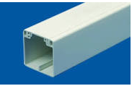
- Wood

- Stainless
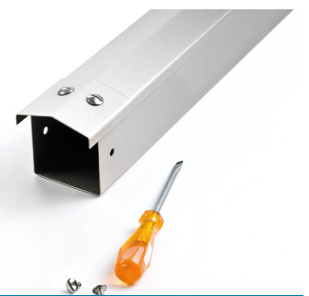
- Cable termination
- twisted pair cabling
- Fiber-optic cabling
- Coaxial cabling
- shielded twisted pair
- Cable Termination
Cable termination is the process of connecting the end of a cable to a specific connector or device. Proper termination is essential for ensuring reliable data transmission and preventing signal loss or interference.
- Twisted Pair Cabling
- Purpose:
Used for Ethernet networks and other data transmission applications.
- Termination Types:
  - RJ-45: The most common termination type for twisted pair cables, used for Ethernet connections.
  - RJ-11: Used for telephone connections.
- Termination Tools: Crimping pliers and RJ-45 connectors.
- Termination Process:
  - Strip the cable to the appropriate length.
  - Insert the wires into the correct positions in the RJ-45 connector.
  - Crimp the connector using crimping pliers.
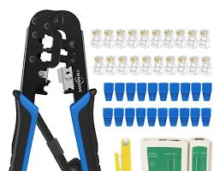Opens in a new windowwww.amazon.com
RJ45 connector and crimping pliers
- Fiber-Optic Cabling
- Purpose: Used for high-speed data transmission over long distances.
- Termination Types:
  - ST: Straight Tip connector.
  - SC: Subscriber Connector.
  - LC: Lucent Connector.
- Termination Tools: Fiber optic cleaver, polishing tools, and fusion splicer.
- Termination Process:
  - Cleave the fiber optic cable to a precise angle.
  - Polish the end of the fiber to remove any imperfections.
  - Connect the fiber to the connector using a fusion splicer.
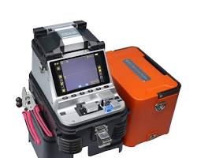Opens in a new windowwww.amazon.com
fiber optic cleaver and fusion splicer
- Coaxial Cabling
- Purpose: Used for cable television, internet, and other high-frequency applications.
- Termination Types:
  - BNC: Bayonet Neill-Concelman connector.
  - F-connector: Used for coaxial cables connecting to televisions or cable modems.
- Termination Tools: Stripping tool and compression tool.
- Termination Process:
  - Strip the coaxial cable to the appropriate length.
  - Connect the center conductor and outer shield to the connector using the compression tool.
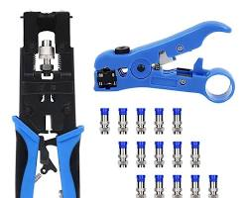Opens in a new windowwww.amazon.com
BNC connector and compression tool
- Shielded Twisted Pair (STP)
- Purpose: Provides additional protection against electromagnetic interference (EMI).
- Termination Types:
  - RJ-45: The same as for unshielded twisted pair (UTP) cables.
- Termination Tools: Crimping pliers and RJ-45 connectors.
- Termination Process: The same as for UTP cables, but the shield must also be properly terminated to ensure effective EMI protection.
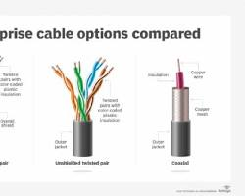Opens in a new windowtechtarget.com
shielded twisted pair cable
Proper cable termination is essential for ensuring reliable network performance and preventing data loss or errors. It is recommended to consult the manufacturer's instructions or seek professional assistance for complex terminations.

Indicative content 1.3: Connection of Network Media
- Labelling
Properly labeling your network cables can be critical for a successful installation, as well as for your network in the long run. Using labeled cables helps prevent people from unplugging the wrong cable at the wrong time,
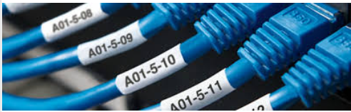
- Patching and Tagging
"Patching and tagging" typically refers to the practice of labeling and organizing network cables, particularly in data centers, server rooms, and structured cabling systems. Proper labeling and organization of network cables are essential for efficient network management, troubleshooting, and maintenance. Here's what "patching and tagging" involves:

1. Patching:

Patching refers to the physical connection of cables. This process involves connecting network cables from active devices (e.g., computers, servers, switches) to passive devices (e.g., patch panels or wall outlets) or to other active devices.
Patch panels are commonly used in data centers and server rooms to terminate and manage network connections. Each port on a patch panel corresponds to a specific location or device.
Cables are connected to the patch panel on one end and to the active devices or wall outlets on the other end, forming the physical links in the network.
2. Tagging:

Tagging involves labeling or tagging each cable with relevant information. This is typically done using cable labels or markers that are affixed to the cables.
Each cable is labeled with information such as its source and destination, cable type (e.g., Cat 6, fiber optic), and unique identifier (e.g., port number, device name).
Cable labels are typically color-coded or otherwise organized to make identification easier.
Patching and tagging offer several benefits in network management:

Easy Identification: Proper labeling allows network administrators to quickly identify the purpose and location of each cable, simplifying troubleshooting and maintenance.

Minimized Downtime: When network issues occur, administrators can pinpoint problems and make repairs more efficiently, reducing network downtime.

Documentation: Accurate labeling provides documentation of network connections, which is valuable for future reference and expansion planning.

Improved Scalability: Well-organized cabling systems make it easier to add, move, or change connections as network requirements evolve.

Compliance and Standards: In some industries and data centers, compliance with labeling and documentation standards is required for regulatory reasons.

- Provide us build design
Designing a network architecture: can be a complex process that depends on various factors, including the organization's requirements, budget, and existing infrastructure. Below is a high-level outline for designing a network, focusing on common components and considerations. Please note that the specific design will vary based on your needs.

1. Requirements Gathering:

Begin by understanding the business requirements and objectives.
Identify the number of users, devices, and the types of applications that will run on the network.
2. Network Topology:

Choose a network topology that suits your needs. Common topologies include star, bus, ring, and mesh.
3. IP Addressing:

Decide on IP addressing schemes, both IPv4 and IPv6, and subnetting.
Plan for address allocation, including static and dynamic addresses.
4. Routing and Switching:

Select appropriate routers and switches. Cisco, Juniper, and other vendors offer various options.
Configure routing protocols (e.g., OSPF, BGP) based on the network's size and complexity.
5. Security:

Implement security measures, including firewalls, intrusion detection/prevention systems, and access control lists (ACLs).
Encrypt sensitive data with technologies like VPNs or SSL/TLS.
6. VLANs (Virtual LANs):
Divide the network into VLANs to segregate traffic and improve security.
Plan VLAN assignments based on department, function, or security requirements.
7. Wireless Networks (Wi-Fi):

If applicable, design the wireless network with considerations for coverage, capacity, and security.
Implement WPA3 security and consider guest networks.
8. Network Management:
Choose network monitoring and management tools (e.g., SNMP, Net Flow).
Set up alerting and reporting to proactively identify and resolve issues.
9. Documentation:
Maintain comprehensive network documentation, including network diagrams, IP address assignments, device configurations, and change logs.
10. Training and Support:
Provide training for network administrators and support staff.

Learning outcome 2: Perform Basic Network Configuration

Indicative content 2.1:Classification of IP Addresses

What Is an IP Address?
IP address stands for internet protocol address; it is an identifying number that is associated with a specific computer or computer network. When connected to the internet, the IP address allows the computers to send and receive information.

How do IP Addresses Work?
An IP address allows computers to send and receive data over the internet. Most IP addresses are purely numerical, but as internet usage grows, letters have been added to some addresses.
- Types of IP Addresses
There are four different types of IP addresses: public, private, static, and dynamic. While the public and private are indicative of the location of the network—private being used inside a network while the public is used outside of a network—static and dynamic indicate permanency.
A static IP address is one that was manually created, as opposed to having been assigned. A static address also does not change, whereas a dynamic IP address has been assigned by a (DHCP) server and is subject to change. Dynamic IP addresses are the most common type of internet protocol addresses. Dynamic IP addresses are only active for a certain amount of time, after which they expire. The computer will either automatically request a new lease, or the computer may receive a new IP address.
An IP address can be compared to a Social Security Number (SSN) since each one is completely unique to the computer or user it is assigned to. The creation of these numbers allows routers to identify where they are sending information on the internet. They also make sure that the correct devices are receiving what is being sent. Much like the post office needs a mailing address to deliver a package, a router needs an IP address to deliver to the web address requested.

What Are the Different Types of IP Addresses?
Consumer IP Addresses: These are the IP addresses of individuals and businesses who use the internet. Consumer IP addresses could be either public or private addresses. Typically, devices use private IP addresses within a network and a public IP addresses outside a network. For example, each device within the same network is assigned a unique private IP address, whereas a public IP can be accessed directly over the internet and is assigned to your network router by your ISP.
Public IP addresses come in two types: dynamic IP addresses and static IP addresses.
Dynamic IP Addresses: A dynamic IP address refers to an address assigned to a device temporarily by an ISP. Dynamic IP addresses are typically assigned to devices such as computers, smartphones, or routers. They provide a level of anonymity and security as the IP address changes periodically, making it more difficult to track a specific device or user. When a device connects to the ISP's network, it is assigned an available IP address from a pool. This address is then borrowed for a specific duration before being returned to the pool and assigned to another device.
Static IP Addresses: A static IP address is a fixed address assigned to a device that remains constant. They are typically used for hosting websites or running servers. By having a fixed IP address, users can easily connect domain names to their servers, ensuring that their websites or services are always accessible. Static addresses are manually configured either on the device itself or by the network administrator. Static IP addresses are typically provided by the user’s ISP or network administrator, and typically come at an additional cost.

IP address versions

What Is IP?
The Internet Protocol (IP) is a set of networking rules that enable computers to communicate over the Internet. IP has two primary purposes:
- Enable different computers to exchange data over the Internet while ensuring sent files arrive at the correct destination.
- Identify every device and domain that connects to the Internet by assigning a unique IP address (a series of digits that identify a specific computer or device).
When you send something online, the IP breaks data into smaller chunks called packets. Each packet has attached IP info that ensures whatever you send reaches the right recipient. This process occurs automatically and looks like this:
- The sender's computer connects to the Internet via a local router, either at home or within an office server room.
- The router (which has a static IP address that never changes) assigns a temporary (a.k.a. dynamic) IP address to the device to enable communication.
- IP converts files into datagrams with a header (info consisting of IP source/destination and metadata) and the payload (the data itself).
- The protocol nests data into packets.
- IP breaks down data packets (fragmentation) and sends them over the Internet to the specified IP address.
- Once data reaches its destination, IP rebuilds the file (reassembly) to allow access.
The Internet Protocol does not assign IP addresses at random. A non-profit organization called Internet Corporation for Assigned Names and Numbers (ICANN) allocates IP addresses to Internet Service Providers (ISPs) who assign addresses to end-user devices.
Most networks combine IP with TCP (Transmission Control Protocol) or UDP (User Datagram Protocol) to form a connection between devices. All three are a part of the broader Internet Protocol Suite (TCP/IP) that governs rules for routing and receiving data over a network.

What Is IPv4?
IPv4 is the first major version of the Internet Protocol that's been the go-to communication model for the Internet since the 1980s.
IPv4 assigns 32-bit IP addresses to devices. Each address has four groups of numbers (8-bit sections called octets) separated by a period, such as:
192.158.1.38
The value of each octet ranges from 0 to 255, so the IPv4 model includes every address between 0.0.0.0 and 255.255.255.255. All IPv4 addresses have two parts:
- The network ID (the first three octets) that indicates which network the device is on.
- The host ID (the fourth octet) that identifies the specific device on that network.
For example, if your home network has a 192.168.1.1 address, 192.168.1 is the network ID, while the final octet (1) is the host ID. In most networks, the router gets the .1 value by default.
IPv4 enables the creation and use of 4,294,967,296 unique addresses (more commonly expressed as 2^32). In the 1980s and 1990s, over 4 billion available addresses seemed sufficient to meet the demand of the online world.
The most common technique for reusing IPv4 addresses is Network Address Translation (NAT). NAT enables you to represent a group of devices with a single IP address, which conserves bandwidth and slows down the depletion(reduction) of IP addresses.
We view IP addresses in human-readable notations, such as 66.94.29.13. However, computers only understand binary format, so the address we see as 66.94.29.13 stands for 01000010.01011110.00011101.00001101 in the "computer language."
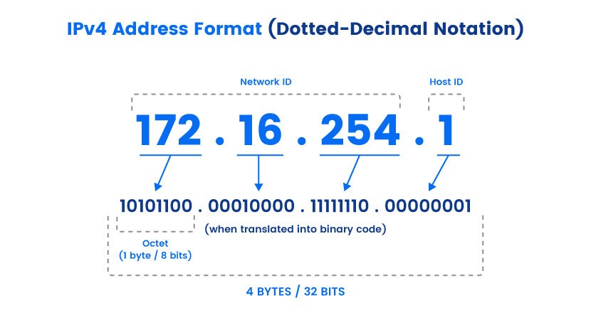

IPv4 Features
Here are the main features of IPv4:
- Creates 32-bit IP addresses.
- Addresses use four 1-byte decimal numbers separated by a dot, a format that a human can easily read and even remember.
- Connectionless protocol.
- Requires small amounts of memory to store address info in the network.
- Supported by nearly all devices and websites on the Internet.
- Offers video libraries and conferences.
- Enables the creation of a simple virtual communication layer over diversified(different) devices.

What Is IPv6?
IPv6 is the latest Internet Protocol version and the successor to IPv4. IPv6 aims to fulfill the need for more IP addresses, the main issue of the previous IP. Another common name for IPv6 is IPng (Internet Protocol next generation).
IPv6 uses 128-bit hexadecimal IP addresses. This model enables 2^128 unique addresses (over 340 undecillion, which is 340 with 36 zeros).
IPv6 addresses are significantly longer than IPv4 variants (eight 16-bit blocks with groups of four symbols, often called hextets or quartets) and are alphanumeric. Also, whereas IPv4 relies on periods for formatting, IPv6 uses colons, such as in this example:
2001:0db8:0000:0001:0000:ff00:0032:7879
The model omits leading zeros (like in IPv4), and you'll sometimes find IP addresses that have a double colon (::) that designate any number of 0 bits (such as 1201:2db7::fa00:0040:6669, in which the third, fourth, and fifth hextets are 0000).
While IPv6 is more sustainable than IPv4, the majority of the Internet still uses IPv4. Upgrading all the routers, servers, and switches that have used IPv4 for decades takes a lot of time and money.

IPv6 Features
Here are the main features of IPv6:
- A 128-bit hexadecimal address scheme.
- Both stateful and stateless configurations.
- Auto-configuration capabilities.
- Support for Quality of Service (QoS).
- Better multicast routing and simpler header format than IPv4.
- End-to-end connectivity at the IP layer, so there's no need for NAT.
- Integrated Internet Protocol Security (IPSec) with built-in authentication, encryption, and privacy support.

IPv4 vs IPv6: What’s the difference?
Both IPv4 and IPv6 identify connected devices on the network. However, there are slight differences in the way they operate. IPv6 is the newer IP version and was introduced to address the limitations IPv4 posed on the availability of IP addresses.
The following is a list of differences between IPv4 and IPv6:
- IPv4 is 32-bit, whereas IPv6 is 128-bit.
- In IPv4, binary bits are separated by a dot (.); IPv6 separates binary bits by a colon (:).
- IPv4 follows the numeric addressing method and IPv6 is alphanumeric.
- IPv4 offers 12 header fields and IPv6 offers eight header fields.
- IPv4 has checksum fields but IPv6 doesn't.
- IPv4 supports broadcast address, which is a type of special address that transmits data packets to every node on the network. IPv6 doesn't support broadcast, but instead uses a multicast address, which is a logical identifier for a collection of hosts on a network.
- IPv4 supports Variable Length Subnet Mask, but IPv6 doesn't.

Looking up an IP address
There are many ways to look up the IP address of a device. However, the simplest way is to type what is my IP address? into an internet browser, such as Google Chrome. The returning address will be the public IP address of the requesting device.

Windows 10 and Windows 11
- Select Start>Settings>Network & internet>Wi-Fi and the Wi-Fi network you're connected to.
- Under Properties, look for your IP address listed next to IPv4 address.

- Identification of IP address classes

IP Address Classification Based on Operational Characteristics
There are three different types of IP addresses within this classification.

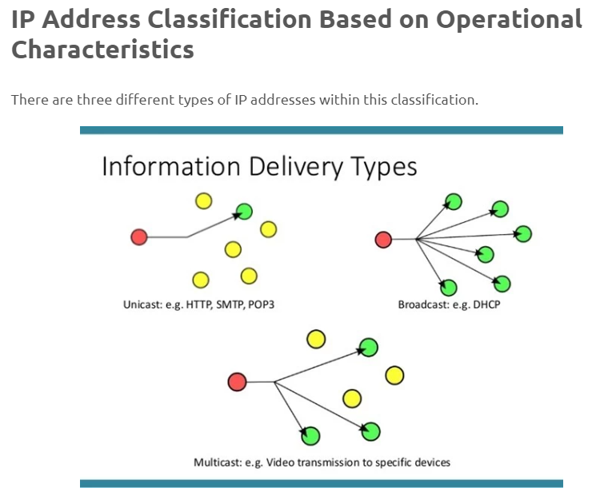

1. Unicast IP Addresses
This is an address of a single interface which are used for one-to-one communication. Unicast IP addresses are used to direct packets to a specific host.

2. Multicast IP Addresses
Multicast IP addresses are used for one-to-many communication. Multicast messages are sent to IP multicast group addresses. The packets reach multiple destinations, however, not every single one of them.

3. Broadcast IP Addresses
This type of IP is used to send data to all the possible destinations within the broadcast domain.

IP Address Terminology
Static means the IP address never changes as long as you stay with the same provider or same server.
Dynamic means the IP address can change from time-to-time.
Public means the IP address can be visited from any computer in the world.
Private means the IP address can only be used by those on the same network.
Shared means other people use your IP address for their connection or websites.
Dedicated means no one else uses your IP address for their connection or websites.
Class identifies the range of your IP address and the default subnet mask.
- A class - 0 to 127 with default mask of 255.0.0.0
- B class - 128 to 191 with default mask of 255.255.0.0
- C class - 192 to 223 with default mask of 255.255.255.0
- D class - 224 to 247 (not currently used)
- E class - 248 to 255 (not currently used)

Identification of IP address classes

There are two versions of IP addresses, IPv4 and IPv6. In this tutorial, we will discuss how IPv4 organizes IP addresses. In IPv4, there are 4,294,967,296 IP addresses. These addresses are organized into five IP classes. These classes are A, B, C, D, and F.
Before we understand how IP addresses are organized in these classes, let's briefly discuss how IP addresses are written and structured.

IP addresses notation
Computers understand only the binary system. The binary system uses bits to store and process data. A bit can store only two values: zero (0) and one (1). If the value 'zero' is stored, the bit is known as the OFF bit. If the value 'one' is stored, the bit is known as ON bit. The binary system uses a unique combination of ON and OFF bits for each letter and number.
Using IP addresses in the binary format is not easy. But the good news is that unless you are a software developer or a network administrator, you never need to write and use IP addresses in binary notation. You can write and use them in decimal format. The software program that you use to assign the IP address on the interface automatically converts the assigned IP address into binary format.
If you are a software developer or a network administrator, you can also use IP addresses in decimal format. But you should also understand how IP addresses work in the binary system. Since interfaces use the binary system to process IP addresses, learning IP addresses in binary format can make your IP related tasks easy.
In short, you can write and use IP addresses in two notations: binary notation and decimal-dotted notation. In binary notation, all the individual bits of each byte are expressed as a binary number. In decimal notation, all four binary bytes are converted and expressed to their decimal equivalent numbers.
In this session,we will understand IP classes in both notations.

IP addresses structure
An IP address consists of 32 bits. These bits are divided into four sections. Sections are separated by a dot (.). Each section contains 8 bits. 8 bits are equal to 1 byte or 1 octet. The following image shows how bits are organized in an IP address.
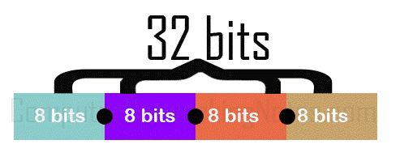
By using 32 bits with two possible values for each position, the binary system can create 4,294,967,296 (2³²) unique combinations or IP addresses. These addresses can be used without any addressing scheme or with an addressing scheme that arranges them in such a way that it becomes easier to access them.
If addresses are used without any addressing scheme, all routers on the network will need to store the address of each and every interface on the network. Depending on the size of the network, this may affect routing. If the network size is small, it can make routing slow. If the network size is moderate, it can make routing very slow. If the network size is large, it can make routing completely impossible.
For efficient routing, addresses are organized into the hierarchical addressing scheme. In this scheme, all addresses are divided into five classes and each address is divided into two addresses: the network address and the host address.

IP address classes
Based on the following rules, IP addresses are categorized into five classes; A, B, C, D, and E.
- In class A, the first bit of the first byte always remains OFF (0).
- In class B, the first bit of the first byte always remains ON and the second bit of the first byte always remains OFF.
- In class C, the first two bits of the first byte always remain ON and the third bit of the first byte always remains OFF.
- In class D, the first three bits of the first byte always remain ON and the fourth bit of the first byte always remains OFF.
- In class E, the first four bits of the first byte always remain ON.
By turning all remaining bits of the first byte ON and OFF, we can make the first and last address of that class.
The following table lists the value of the first byte or octet in both notations.
Class | Fix bits | First address (binary notation) | Last address (binary notation) | First address (decimal notation) | Last address (decimal notation)
A | 0 | 00000000 | 01111111 | 0 | 127
B | 10 | 10000000 | 10111111 | 128 | 191
C | 110 | 11000000 | 11011111 | 192 | 223
D | 1110 | 11100000 | 11101111 | 224 | 239
E | 1111 | 11110000 | 11111111 | 240 | 255

Network and host addressing
In the second level of the hierarchical addressing scheme, each address is further divided into two addresses: the network address and host address.
Network addresses are used to combine multiple IP addresses in a group while host addresses are used to provide a unique identity to each IP address in the group. A network address is the group address. All group members use the same network address. A host address is a unique address in the group.
To learn more about how the network addresses and host addresses work, you can check the following tutorial.
IP address, Network address, and Host address Explained
The length of network addresses and host addresses in IP addresses are different in all IP classes. In class A, the first bits are reserved for the network address. The remaining 24 bits are available for the host address. In class B, the first 16 bits are reserved for the network address while the last 16 bits are available for the host address. In class C, the first 24 bits are reserved for the network address while the last 8 bits available for the host address.
The following image shows how bits are defined for network addresses and host addresses in each IP class.
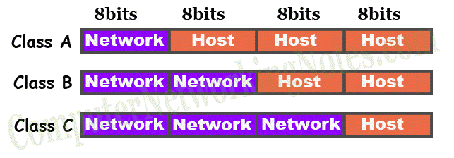
In IP addresses, host bits are flexible. Administrators can adjust the length of host bits to meet the requirements of their networks. They can use host bits as network bits to utilize maximum addresses from all available addresses. If hosts bits are used as the network bits, this is known as the subnetting.
Class D and E are not used for the host addressing. Class D addresses are used for multicast addresses. Class E addresses are reserved for research and development purposes. Multicast addresses are explained in the following tutorial.

The subnet mask
IP addresses use an additional component to distinguish between network addresses and host addresses. This component is known as the subnet mask. In simple words, the subnet mask tells, how many bits in the IP address are used as the network address and how many bits are left for the host address.
IP addresses are always written with the subnet mask. The following table lists the default subnet mask for all IP classes.
Class | Decimal notation | Binary notation
A | 255.0.0.0 | 11111111.00000000.00000000.00000000
B | 255.255.0.0 | 11111111. 11111111.00000000.00000000
C | 255.255.255.0 | 11111111. 11111111. 11111111.00000000

Identifying the class of an IP address (decimal notation)
If an IP address is written in the decimal notation, check the value of the first section or octet and use the following rules to identify the class of the IP address.
- If the value is in the range 1 to 127, the address belongs to class A.
- If the value is in the range 128 to 191, the address belongs to class B.
- If the value is in the range 192 to 223, the address belongs to class C.
- If the value is in the range 224 to 239, the address belongs to class D.
- If the value is in the range 240 to 255, the address belongs to class E.

Identifying the class of an IP address (binary notation)
If an IP address is written in the binary notation, you can use the following rules to identify the class of the IP address.
- If the first bit is OFF, the address belongs to class A.
- If the first bit is ON and the second bit is OFF, the address belongs to class B.
- If the first two bits are ON and the third bit is OFF, the address belongs to class C.
- If the first three bits are ON and the fourth bit is OFF, the address belongs to class D.
- If the first four bits are ON, the address belongs to class E.

Examples of IP addresses
Decimal notation | Binary notation
1.2.3.4  255.0.0.0 | 00000001.00000010.00000011.00000100  11111111.00000000.00000000.00000000
10.10.10.10  255.0.0.0 | 00001010.00001010.00001010.00001010  11111111.00000000.00000000.00000000
25.147.191.14  255.0.0.0 | 00011001.10010011.10111111.00001110  11111111.00000000.00000000.00000000
95.86.75.4  255.0.0.0 | 01011111.01010110.01001011.00000100  11111111.00000000.00000000.00000000
127.0.0.1  255.0.0.0 | 01111111.00000000.00000000.00000001  11111111.00000000.00000000.00000000
Examples of class A IP addresses are the following.
Examples of class B IP addresses are the following.
Decimal notation | Binary notation
129.12.36.42  255.255.0.0 | 10000001.00001100.00100100.00101010  11111111.11111111.00000000.00000000
168.172.1.1  255.255.0.0 | 10101000.10101100.00000001.00000001  11111111.11111111.00000000.00000000
175.66.43.12  255.255.0.0 | 10101111.01000010.00101011.00001100  11111111.11111111.00000000.00000000
145.186.175.234  255.255.0.0 | 10010001.10111010.10101111.11101010  11111111.11111111.00000000.00000000
190.60.152.25  255.255.0.0 | 10111110.00111100.10011000.00011001  11111111.11111111.00000000.00000000
Examples of class C IP addresses are the following.
Decimal notation | Binary notation
192.168.1.1  255.255.255.0 | 11000000.10101000.00000001.00000001  11111111.11111111.11111111.00000000
210.20.30.40  255.255.255.0 | 11010010.00010100.00011110.00101000  11111111.11111111.11111111.00000000
216.123.145.16  255.255.255.0 | 11011000.01111011.10010001.00010000  11111111.11111111.11111111.00000000
220.86.76.43  255.255.255.0 | 11011100.01010110.01001100.00101011  11111111.11111111.11111111.00000000
220.60.80.100  255.255.255.0 | 11011100.00111100.01010000.01100100  11111111.11111111.11111111.00000000

Indicative content 2.2:Calculation of IP addresses subnet masks
- Introduction to subnet masks
A subnet mask is a 32-bit number created by setting host bits to all 0s and setting network bits to all 1s. In this way, the subnet mask separates the IP address into the network and host addresses. The “255” address is always assigned to a broadcast address, and the “0” address is always assigned to a network address.
- Definition:Subnetting is the process of dividing a large network into smaller, more manageable subnetworks or subnets. It offers several benefits in terms of network management, security, and efficiency. Here are some of the key benefits of subnetting:

- Benefits of subnetting
Efficient IP address utilization: Subnetting allows you to break down a large IP address space into smaller segments, which helps optimize the allocation of IP addresses. This is especially important in a world where IPv4 addresses are becoming increasingly scarce.
Network segmentation: Subnets can be used to logically segment a network, which enhances network organization and management. Different subnets can be assigned to different departments, teams, or functions within an organization, making it easier to manage and troubleshoot network issues.
Improved network performance: Smaller subnets can reduce broadcast traffic, as broadcast packets are limited to the devices within the same subnet. This helps improve overall network performance by reducing unnecessary network traffic.
Enhanced security: Subnetting can be used to isolate sensitive or critical parts of a network from the rest of the network. This provides an additional layer of security by limiting the scope of potential security breaches or attacks.
Simplified troubleshooting: When a network is divided into smaller subnets, it becomes easier to identify and isolate issues. Troubleshooting and diagnosing problems are more efficient because you can narrow down the affected portion of the network.
Improved network management: Subnetting simplifies the management of IP addresses, routing tables, and network devices. It enables network administrators to apply access control policies, quality of service (QoS), and other network services more effectively.
Questions

Q. Why use subnets?
A. Subnets will enhance network security, efficiency, and performance, and create a speedier set of route maps for data.

Q. How can my company use subnets?
A. Locate a highly qualified engineer by utilizing the search function at Field Engineer.

Q. How many hosts can a subnet have?
A. If you subtract the number of network bits from the number of total bits, you can calculate the total number of hosts a subnet can have.

Q. What sort of networks would be best for subnetting?
A. Small networks don’t require subnets. However, large LANs are prime candidates as IP address allocation will be impactful with group devices to maximize organization.

Q. What is an IP class?
A. IP classification is complex. However, in layman’s terms, IP classes range from A - E. Class A, B, and C are used for host addresses without exception. Class D is for multicasting. And Class E is rarely used within networks of companies.

- ✓Binary system

The binary system is a numeral system that uses a base of 2. In contrast to the decimal system, which uses base 10 and has ten digits (0 through 9), the binary system uses only two digits: 0 and 1. This system is fundamental in computer science and digital electronics because it aligns with the binary logic of on and off, high and low voltage, and true and false states.

Here are some key points about the binary system:

Digits: In the binary system, each digit is called a "bit," which is short for "binary digit." A bit can have one of two values, either 0 or 1.

Place Value: Just like in the decimal system, the binary system uses place value. Each position from right to left represents a power of 2. For example, in the binary number 1101, the rightmost digit is 2^0, the next is 2^1, the next is 2^2, and the leftmost digit is 2^3.

Counting: Counting in binary follows a simple pattern. It goes from 0 (represented as 0 in binary) to 1 (also represented as 1 in binary). Then, when you add 1 to 1, it "carries over" just like in the decimal system, becoming 10 in binary (which is equivalent to 2 in decimal). The pattern continues: 11 (3 in decimal), 100 (4 in decimal), 101 (5 in decimal), and so on.

Conversions: Binary numbers can be converted to decimal and vice versa. To convert a binary number to decimal, you multiply each bit by the corresponding power of 2 and sum the results. For example, 1101 in binary is 12^3 + 12^2 + 02^1 + 12^0, which equals 13 in decimal. To convert from decimal to binary, you repeatedly divide the decimal number by 2 and record the remainders until the quotient becomes zero.

Representation in Computers: Computers use binary internally to represent all data and instructions. Each piece of data, such as numbers, characters, and even the program itself, is represented in binary. This is because digital electronic devices work with electrical voltage that can be either high (1) or low (0).

Boolean Logic: The binary system aligns with Boolean logic, where 0 typically represents "false" or "off," and 1 represents "true" or "on." This is fundamental in computer programming and digital circuit design.

Binary is the basis for all digital communication and computation. It's used for encoding, storage, processing, and transmission of data in computers and other digital systems, making it a fundamental concept in the field of information technology.

- Types of Subnetting

There are two types of Subnetting FLSM and VLSM. In FLSM, all subnets have equal number of host addresses and use same Subnet mask. In VLSM, subnets have flexible number of host addresses and use different subnet mask.

FLSM Subnetting and VLSM Subnetting
There are two types of Subnetting: FLSM and VLSM. In FLSM, all subnets have an equal number of host addresses and use the same subnet mask. In VLSM, subnets have a flexible number of host addresses. They use a subnet mask based on the number of hosts.
Default IP subnets have a large number of IP addresses. Most networks do not need too many IP addresses. If they use the default subnet, all unused IP addresses become useless. To utilize free IP addresses, we use subnetting.
Subnetting allows us to break default IP subnets. There are two types of subnetting: FLSM and VLSM.
FLSM stands for Fixed Length Subnet Mask. In it, we break the default IP subnet into the same-sized subnets. For example, if the default subnet has 12 IP addresses, we can break it into three equal-sized subnets having 4 IP addresses in each.
VLSM stands for Variable Length Subnet Mask. In it, we break the default IP subnet into subnets having various sizes. For example, if the default subnet has 12 IP addresses, we can break it into two subnets where the first subnet has 8 IP addresses and the second subnet has 4 IP addresses.

Differences between FLSM Subnetting and VLSM Subnetting
The following table lists the differences between FLSM and VLSM.
FLSM (Fixed Length Subnet Masks) Subnetting | VLSM (Variable Length Subnet Masks) Subnetting
All subnets are equal in size. | Subnets are variable in length.
All subnets have an equal number of hosts. | Subnets have a variable number of hosts.
All subnets use the same subnet mask. | Subnets use different subnet masks.
It is easy to configure and manage. | It is complex in configuration and administration.
It wastes a lot of IP addresses. | It wastes minimum IP addresses.
It is also known as classful subnetting. | It is also known as classless subnetting.
It supports both classful and classless routing protocols. | It supports only classless routing protocols.

Indicative content 2.3: Assigning IP Address

Understanding IP Addresses
An IP (Internet Protocol) address is a numerical label assigned to each device connected to a computer network that uses the Internet Protocol. It serves as a unique identifier for devices to communicate with each other.

Types of IP Address Assignment

1. Static IP Address
- Definition: A static IP address remains constant and is manually assigned to a device.
- Advantages:
  - Predictability: Devices can always be found at the same IP address.
  - Security: Can be used for network security measures like firewalls.
- Disadvantages:
  - Manual Configuration: Requires manual setup for each device.
  - Limited Scalability: Can be challenging to manage in large networks.
- Use Cases:
  - Servers
  - Network devices (routers, switches)
  - Devices requiring consistent access (e.g., printers, webcams)

2. Dynamic IP Address
- Definition: A dynamic IP address is assigned automatically from a pool of available addresses. It is often temporary and may change when a device reconnects to the network.
- Advantages:
  - Scalability: Easily accommodates changes in network size.
  - Efficiency: Optimizes address usage.
- Disadvantages:
  - Inconsistency: Devices may have different IP addresses each time they connect.
  - Potential for Conflicts: If not managed properly, IP address conflicts can occur.
- Use Cases:
  - Client devices (computers, smartphones, tablets)
  - Temporary network connections

3. Automatic IP Address (DHCP)
- Definition: DHCP (Dynamic Host Configuration Protocol) is a network protocol that automatically assigns IP addresses to devices. It uses a central server to manage the pool of available addresses.
- Advantages:
  - Automation: Simplifies network management.
  - Scalability: Easily handles changes in network size.
  - Efficiency: Optimizes address usage.
- Disadvantages:
  - Dependence on DHCP Server: Network relies on a functioning DHCP server.
  - Potential for Conflicts: If not configured correctly, IP address conflicts can occur.
- Use Cases:
  - Most network environments, especially those with a large number of devices.

Choosing the Right Method
The best IP address assignment method depends on your network's specific needs and size. Consider the following factors when making a decision:
- Network Size: Larger networks often benefit from dynamic or automatic assignment.
- Security Requirements: Static IP addresses can provide more control over network security.
- Device Requirements: Some devices, like servers, may require static IP addresses for consistent access.
- Management Complexity: Dynamic or automatic assignment can simplify network management.

Indicative content 2.3: Configuration of Basics Network Device.

Configuring Basic Network Devices: A Step-by-Step Guide

Understanding Device Configuration Modes
Network devices typically operate in two primary modes:
- User Mode: This is the default mode where you can view device information but cannot make changes.
- Privileged Mode: To access privileged mode, you'll need to enter a password. This mode allows you to configure device settings.

Common Configuration Tasks

1. Setting Hostname
- Purpose: Assigns a unique name to the device for identification.
- Command: hostname <new_hostname>
  - Example: hostname myrouter

2. Creating a Banner Message
- Purpose: Displays a message when someone connects to the device.
- Command: banner motd <message>
  - Example: banner motd Unauthorized access is prohibited.

3. Reloading the Device
- Purpose: Restarts the device, often used after making configuration changes.
- Command: reload

4. Configuring Ports
- Purpose: Controls port settings, such as enabling or disabling ports, setting speed, and duplex mode.
- Commands:
  - interface <interface_type> <interface_number>
  - no shutdown (enables the port)
  - shutdown (disables the port)
  - speed <speed>
  - duplex <full|half>

5. Configuring Device Passwords
- Purpose: Protects access to the device.
- Commands:
  - enable password <password> (sets the enable password)
  - line console 0 (configures the console port)
  - password <password> (sets the console password)

6. Saving the Configuration
- Purpose: Stores the current configuration settings.
- Command: copy running-config startup-config

Example Configuration
hostname myrouter
banner motd Unauthorized access is prohibited.
interface gigabitEthernet0/0
no shutdown
speed 1000
duplex full
enable password mystrongpassword
line console 0
password myconsolepassword
copy running-config startup-config

indicative content 2.4: Testing network Interconnection

Testing Network Interconnection

Physical Testing
Purpose: To verify the physical connectivity between devices.Tools: Cable testers, continuity checkers, optical power meters.Steps:
- Inspect Cables: Visually check for any physical damage, such as cuts, bends, or kinks.
- Test Connectivity: Use a cable tester to ensure proper connection between the cable and the device ports.
- Measure Signal Strength: For optical fibers, use an optical power meter to measure the signal strength.

Unit Testing
Purpose: To test individual components of the network, such as routers, switches, and servers.Tools: Ping, traceroute, telnet, SSH.Steps:
- Isolate Component: Disconnect the component from the network to test it in isolation.
- Perform Basic Tests: Use ping to test connectivity between the component and other devices.
- Check Configuration: Verify that the component's configuration is correct and consistent with network requirements.
- Test Functionality: Use appropriate tools (e.g., telnet, SSH) to test the component's specific functions.

Integration Testing
Purpose: To test the interaction between multiple components of the network.Tools: Network analyzers, packet sniffers.Steps:
- Simulate Network Traffic: Generate realistic network traffic patterns to test the network's performance under load.
- Monitor Performance: Use network analyzers to monitor key performance indicators, such as latency, throughput, and packet loss.
- Identify Bottlenecks: Analyze the network traffic to identify any bottlenecks or performance issues.
- Test Fault Tolerance: Simulate failures to assess the network's ability to recover from disruptions.

Learning outcome 3: Maintain Network system

Indicative content 3.1: Perform preventive maintenance.
- Hardware Preventive Maintenance
1. Schedule Regular Cleaning:
- Frequency: Clean devices at least once a month, or more frequently in dusty environments.
- Cleaning Methods: Use compressed air or a soft, dry cloth to remove dust and debris from devices. Avoid using harsh chemicals or liquids.
2. Setting of Preventive Measures:
- Environmental Factors: Ensure devices are placed in a cool, dry environment with adequate ventilation.
- Power Protection: Use surge protectors or uninterruptible power supplies (UPS) to safeguard devices from power fluctuations and outages.
- Physical Security: Implement physical security measures, such as locking cabinets or using security cameras, to prevent unauthorized access.
3. Check Physical Equipment Condition:
- Inspect Cables: Regularly inspect cables for signs of wear, fraying, or damage. Replace damaged cables promptly.
- Check Connectors: Ensure that connectors are securely fastened and free of corrosion.
- Examine Cooling Systems: Verify that fans and cooling systems are operating properly.
4. Check Environment Condition:
- Temperature and Humidity: Monitor temperature and humidity levels to ensure they are within the recommended range for network devices.
- Air Quality: Maintain good air quality to prevent dust and other contaminants from accumulating on devices.
- Software Preventive Maintenance
1. Regular Change of Network Device Credentials:
- Frequency: Change passwords for network devices at least every six months.
- Complexity: Use strong, complex passwords that are difficult to guess.
2. Network Monitoring Software Licensing/Application:
- License Compliance: Ensure that network monitoring software is licensed correctly and in compliance with usage terms.
- Application: Properly configure and deploy network monitoring software to effectively monitor network performance and identify potential issues.
3. Updating and Upgrading Network Monitoring Software and Device Firmware:
- Regular Updates: Keep network monitoring software and device firmware up-to-date with the latest patches and security updates.
- Upgrade Planning: Plan upgrades carefully to minimize downtime and ensure compatibility with existing systems.
- Testing: Test updates and upgrades in a controlled environment before applying them to production networks.

Indicative content 3.2: Perform corrective maintenance.

- Hardware Corrective Maintenance
1. Identification of Common Problems and Their Causes:
- Symptom Analysis: Identify common symptoms of network problems, such as slow performance, connectivity issues, or device failures.
- Root Cause Analysis: Determine the underlying causes of these problems, which may include hardware faults, software errors, or environmental factors.
2. Repair/Replace Damaged Equipment:
- Component Isolation: Isolate the faulty component to prevent further damage to the network.
- Repair or Replacement: If possible, repair the damaged component. If repair is not feasible, replace it with a compatible spare.
- Testing: Thoroughly test the repaired or replaced component to ensure it is functioning properly.
- Software Corrective Maintenance
1. Troubleshoot Network Configuration:
- Configuration Review: Review network configuration files for errors, inconsistencies, or conflicts.
- Testing: Use appropriate tools (e.g., ping, traceroute) to test network connectivity and identify specific issues.
- Configuration Adjustments: Make necessary adjustments to the configuration to resolve problems.
2. Check Network Status:
- Monitoring Tools: Use network monitoring tools to gather information about network performance, traffic patterns, and device status.
- Identify Anomalies: Look for any anomalies or deviations from normal behavior that may indicate problems.
3. Update Network Configuration:
- Configuration Changes: Apply any necessary configuration changes to address identified issues or improve network performance.
- Testing: Test the updated configuration to ensure it is working as expected.

Indicative content 3.3: Troubleshooting network

Introduction to Troubleshooting
Troubleshooting is the process of identifying, isolating, and resolving problems in a network. It involves a systematic approach to gather information, analyze the situation, and implement solutions. Effective troubleshooting requires a combination of technical knowledge, problem-solving skills, and patience.

Troubleshooting Process
- Collecting Network System Information:
  - Gather Basic Information: Collect information such as device types, IP addresses, and network topology.
  - Check Logs: Review system logs for error messages or unusual activity.
  - Gather Performance Metrics: Monitor network performance metrics like latency, throughput, and packet loss.
- Analyzing Current Network Status:
  - Identify Symptoms: Determine the specific symptoms of the problem, such as connectivity issues, slow performance, or device failures.
  - Isolate the Problem: Narrow down the potential causes of the problem by isolating components or networks.
  - Test Connectivity: Use tools like ping, traceroute, and netstat to test connectivity between devices.
- Identification of Common Problems:
  - Hardware Failures: Check for physical damage to cables, devices, or connectors.
  - Software Issues: Review configuration files, update drivers or firmware, and check for software conflicts.
  - Network Congestion: Monitor network traffic and identify potential bottlenecks.
  - Security Threats: Check for signs of security breaches, such as unauthorized access or malware infections.
- Implementation of Solutions:
  - Apply Fixes: Implement solutions based on the identified problem, such as replacing faulty hardware, updating software, or adjusting network settings.
  - Test and Verify: Thoroughly test the implemented solutions to ensure they have resolved the problem.
  - Document Solutions: Document the troubleshooting process, including the problem, solution, and any lessons learned.

Indicative content 3.4: Elaboration of maintenance report
- Ways of Reporting
1. Oral Reporting:
- Verbal Presentation: Provide a clear and concise verbal explanation of the maintenance activities performed.
- Meetings: Participate in meetings or conferences to discuss maintenance reports and address questions.
2. Written Reporting:
- Maintenance Logs: Maintain detailed logs of maintenance activities, including dates, times, tasks performed, and any issues encountered.
- Formal Reports: Prepare formal written reports that summarize the maintenance activities, outcomes, and recommendations.
3. Video Documentation:
- Visual Evidence: Record video footage of maintenance activities to provide visual evidence and enhance understanding.
- Time-Lapse Photography: Use time-lapse photography to capture the progress of long-term maintenance projects.

Report Elements
1. Used Tools, Materials, and Equipment:
- List of Items: Clearly list all tools, materials, and equipment used during the maintenance activities.
- Quantities: Specify the quantities of each item used.
- Supplier Information: Provide information about the suppliers of tools, materials, and equipment.
2. Status After Maintenance:
- Performance Assessment: Evaluate the performance of the system or equipment after maintenance.
- Issue Resolution: Indicate whether any issues were resolved during the maintenance activities.
- Recommendations: Provide recommendations for future maintenance or improvements.
3. Updates to Built Design:
- Changes: Describe any changes made to the built design as a result of maintenance activities.
- Reasoning: Explain the rationale for the changes and their impact on the system's performance or reliability.
4. Recommendations:
- Future Maintenance: Provide recommendations for future maintenance tasks or schedules.
- Improvements: Suggest improvements to the system or equipment to enhance performance or reduce maintenance requirements.
- Cost-Benefit Analysis: Evaluate the cost-benefit of proposed improvements.

…………………………………END OF MODULE…………………………….

